**DATA FLOW DIAGRAM**

**LEVEL ZERO DFD**

BLOCKCHAIN SERVER

LAB

PATIENT

DOCTOR

**LEVEL 1 DFD**

PATIENT

DOCTOR

BLOCKCHAIN SERVER

**LEVEL 2 DFD**

DOCTOR

BLOCKCHAIN SERVER

LAB

**USECASE DIAGRAM**

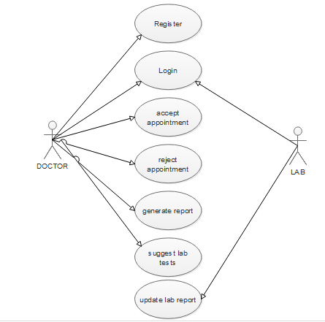

**SEQUENCE DIAGRAM**

